|  |  |  |  |
| --- | --- | --- | --- |
| **NAME:** |  | **DATE:** |  |

PRACTICE EXERCISE # 1

1. Algorithm Title 1

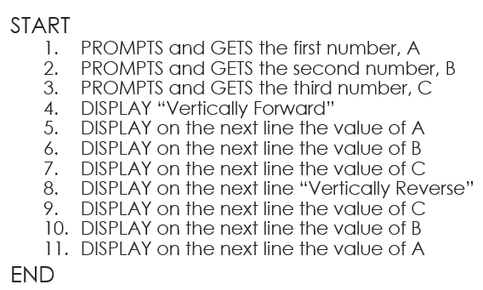

1. Algorithm Title 2

